**SHARON MILLEN.**

My name is Sharon and I received my first liver transplant in Jan 1997 when I was still at school, and this changed my whole life course. Prior to my illness, I was on a path to study music at university. I had played the piano since the age of 5 and was studying music as one of my A-levels. However, a career in music was not to be. Before I completed my A-levels I took ill and required an urgent liver transplant after which I spent a few months in St Vincent’s hospital in Dublin recovering. Throughout this time, I experienced a lot and came to the realisation that I wanted to study psychology and try to help others on their journey through transplant. It was evident to me that patients were struggling with a range of psychosocial challenges as a result of their experience and that this area required more attention. A few months after I was discharged, I started an A-level in psychology which then led to a diploma followed by a degree. This then enabled me to complete a PhD in Health Psychology during which I was able to work directly with a group of liver patients and examine their psychological wellbeing from pre-transplant through various key stages of recovery post-transplant. It was evident that patients could benefit from some form of psychosocial support. I started working as a psychologist in the area of research at Queen’s university in 2008 and around the same time was invited to join the committee of the RVH Liver Support Group. I have been part of the committee ever since and this role has provided me with many opportunities to help and support others with liver conditions.

I received a second lifesaving liver transplant in 2016 and to date, my two transplants have given me over 26 extra years of life which I wouldn’t otherwise have had. Because of organ donation, my health has been restored and this has allowed me to compete in the British Transplant Games a number of times through which I have met many amazing transplant recipients. I have also been able to continue working as a researcher at Queen’s and enjoy a full and rewarding life with great friends and family for which I am extremely grateful.

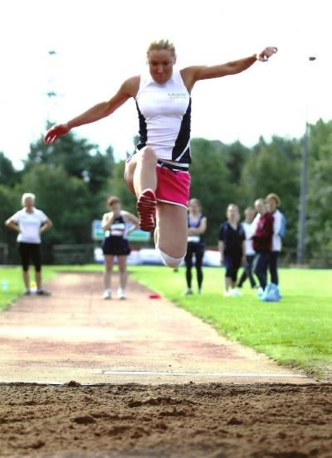 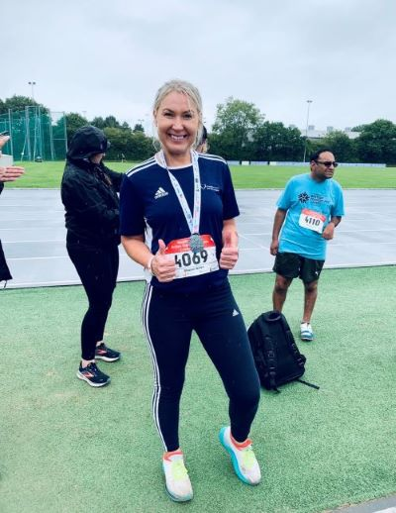

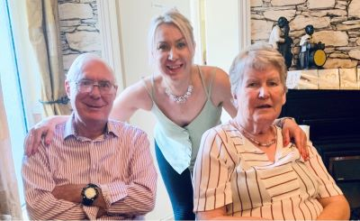

**PATRICIA GETTY.**

Hi My Name is Patricia and I received my Liver Transplant in May 2019 and it certainly was a momentous time in my life. I had been suffering from an Auto-Immune condition for in excess of ten years which had been managed very well for most of this time. Only in the last year before transplant did my condition worsen so much that I was put on the Transplant list. I was wonderfully cared for by the teams in the RVH and Kings Hospital London.

Post Transplant my life changed dramatically with new found energy and zest. I returned to do many of the activities I had enjoyed in the past. I had a greater appreciation of every moment I have from the spring in my step to the better serve in my tennis to cold water swimming and Pilates. I embrace life as fully as possible enjoying great family times as my children grow into adulthood and I have the energy to look after my two very young grandchildren. Family holidays are joyful celebrations and I rejoice in every newfound opportunity that comes my way.

Organ Donation Week is a great way to help others realise the importance of donation, a great celebration for those who have benefitted from transplant and a time to remember those who have helped others with the gift of life.

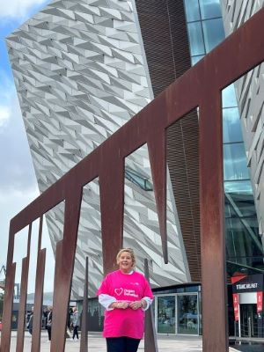

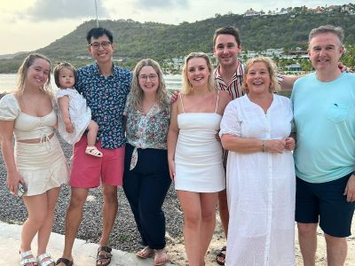

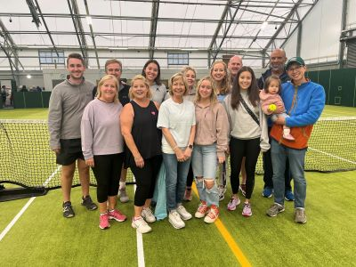

**JIM KILPATRICK.**

My liver disease journey has been brief compared to many others, however like most, it has been eventful to say the least.

My non-alcoholic cirrhosis was diagnosed just six weeks after I began my early retirement in April 2017, and came as a shock at the time.  I'd had a few minor health issues beforehand, but this was on another scale.  It did however explain a lot when I put all the pieces of the jigsaw together.  I had a drain done of my ascites, I changed my diet under supervision, and began living with liver disease.  At the start of 2018 my health deteriorated rapidly and forcefully, ending with a transplant on 2nd April 2018, which happened to be Easter Monday.

Thankfully my body recovered quickly and I was back in the house again from King's within two weeks.  I'd lost a large amount of weight (some seven and a half stone) and soon began rebuilding muscle mass and strength.  I was determined to follow my mantra of "Life is to be enjoyed, not endured", and happily told everyone that I was going to live life to the full after being given this opportunity by my donor Leslie, and his wife Val.

My wife and I are avid travellers, going around the UK in our touring caravan. and also flying to numerous countries across Europe and beyond.  The urge to restart after transplant came early, and just three months Pilates. I after my operation we restarted our caravanning, heading to Portrush for the first outing.  A month later we flew to Germany for a well-deserved and totally relaxing river cruise on the Rhine and the Moselle, ending with a few days in Zurich.  We were back!  The caravan was on the road more and more, including a beautiful tour of Devon and Cornwall in 2019.  Plans were soon being made for a more adventurous trip starting in late February 2020 going round the world via the USA, New Zealand, Australia and Singapore.  Covid-19 however brought that to a halt while we were in New Zealand, leading to a pretty rapid return home to the UK and the lockdowns which then faced the country.

Family life carried on of course, and in September 2021 our daughter Jane and her boyfriend Michael announced they were planning on getting married.  This was wonderful news, and the wedding took place earlier this year in the Folk Museum at Cultra.  It was fantastic to be able to experience the day, all thanks to the gift of life provided to me by Leslie five years earlier.  His widow Val and I had been communicating by letter since August 2018, and were getting on extremely well, feeling more and more comfortable with each other as each letter arrived.  We decided it would be lovely to invite her to the wedding, which she accepted, and we had our first face-to-face meeting.  We speak to each other on the phone every week or so, and she is now an integral part of our family, as we are in hers.

I decided last year to participate in the British Transplant Games for the first time, also returning this year.  As Chairman of the Liver Support Group, I wanted to demonstrate to our members that age is no barrier to enjoying the Games, and we should all try something new which we've never done before.  The camaraderie at the Games, and in particular in the Transplant Sport NI team, is quite unbelievable.  With a thousand or so participants taking part from across the UK, all of whom are alive only because of transplantation, it's quite a humbling experience.  I look forward to next year's competition in Nottingham.

Life is all about experiences, and as an organ recipient, I have been given the chance to enjoy many more.  I thoroughly intend to do so at every opportunity.

