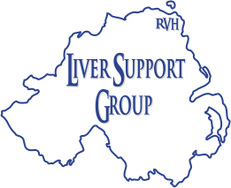 RVH LIVER SUPPORT GROUP

Charity No. NIC 100892

Come Dine With Us!

You are warmly invited to join the RVH Liver Support Group for a Carvery Lunch

- Seagoe Hotel, Portadown - Sunday 2nd June 2019 @ 3pm

- Free of charge to all members plus one guest

(If you wish, you can bring other guests at a cost of £22.95 per person)

Following previous enjoyable afternoons at Seagoe, this will be an excellent opportunity to meet with members and friends of the Group.

Please inform Donald Cairnduff, Hon Secretary, if you are coming and how many places you wish to book - via text, email or post before FRIDAY 24th May

Text: 07701029347

E-mail: dcairnduff@msn.com

Postal Address: Donald Cairnduff, 2 Grangewood Manor, Dundonald, BT16 1GJ

(If you are bringing other guests, please post a cheque for the appropriate amount to the above address).

We look forward to seeing you

