BSSCII
British Society for Skin Care
In Immunosuppressed Individuals
Patient information
Skin care after
an organ transplant
Also for those who have a
suppressed immune system
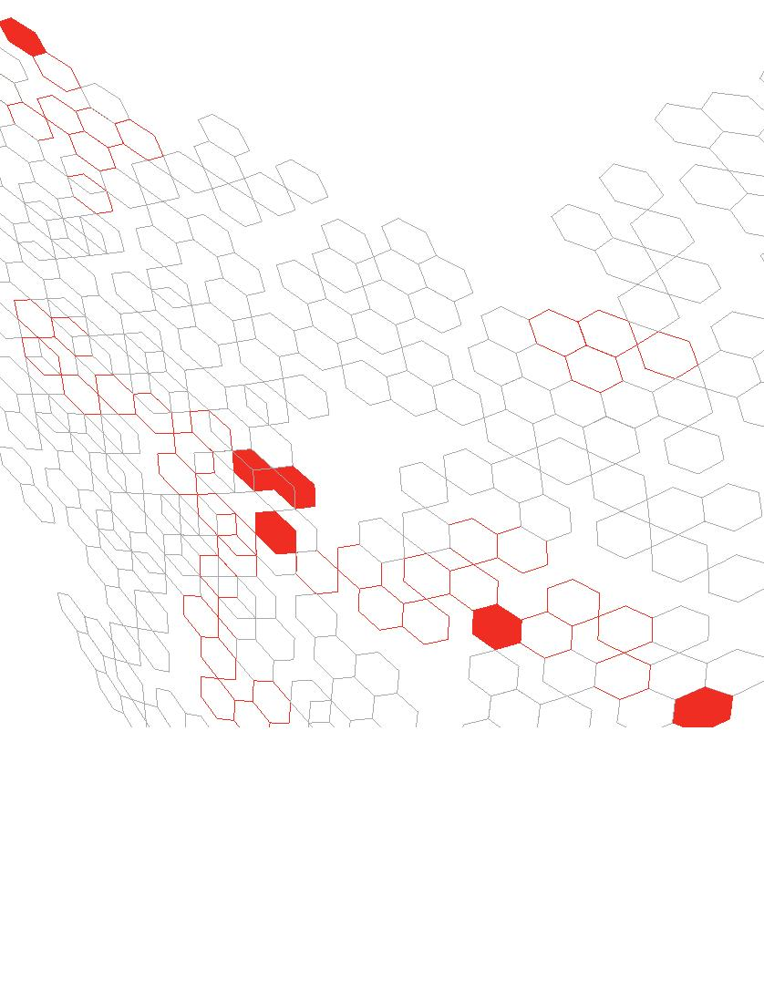

Contents
www.bartshealth.nhs.uk
Introduction
............................................................................................................................
4
About the transplant skin clinic
........................................................
5–7
Common skin conditions after transplant
....................
8–31
This booklet has been produced by
Barts Health NHS Trust and funded
by Barts Charity.
List of conditions
.....................................................................................................................
8
Skin cancer prevention
..........................................................................
32–36
Skin self-examination
Body diagrams
Sun protection and vitamin D
..........................................................................................
32–34
......................................................................................................................
35
36
................................................................................
www.bartscharity.org.uk
Dermatology department contact numbers
Further information
Patient diary
....................
37
37
................................................................................................
...........................................................................................................
38–43
3

Introduction
About the transplant skin clinic
at Barts Health NHS Trust
You are more likely to suffer from various skin problems after an
organ transplant because you are taking immunosuppressive
(anti-rejection) drugs. Your body is less able to ﬁght certain skin
conditions effectively, mainly because your immune system is
being suppressed.
The transplant skin clinic is part of the dermatology
department. It is run by dermatologists for monitoring,
preventing and treating skin problems in patients who have
had an organ transplant or who are immunosuppressed
(immunocompromised) for other reasons.
This booklet has been produced to help you look after your
skin following a transplant. Much of the advice is also appropriate
for people who have a suppressed immune system due to other
causes such as chronic lymphocytic leukaemia (CLL) and HIV,
and for those awaiting an organ transplant.
It is one of the biggest centres for this specialty in the UK.
Our doctors and nurses aim to see you within 12 months of
your transplant to alert you to any possible skin problems
that might arise, and to assess your individual risk for skin
cancer. They will give you advice and guidance on how to look
after your skin. Depending on your risk factors and individual
needs, you will be advised how frequently you need to be
seen thereafter – usually between one and ﬁve years.
The booklet gives you information on what signs and symptoms
to look out for, and describes the treatment for a variety of
skin conditions. There is also a useful chapter on skin cancer
prevention including how to examine your skin and protect
yourself from exposure to the sun.
An important part of the work of this clinic is research on
skin disease and skin cancer after transplantation, with a
view to preventing and improving these conditions. We may
ask whether you would be willing to participate in one of the
research studies being undertaken by the clinic.
At the back is a patient diary for you to write down the outcome
of your clinic visits and any comments about your skin condition.
Please bring this booklet with you when you come to the
transplant skin clinic.
4
5

How often will I be seen in the clinic?
Follow-up appointments
This will depend upon your risk of developing skin problems.
Our aim is to detect new or suspicious skin lumps early so that
we can treat them as soon as possible.
For some of you the risk of developing skin problems is so low
that we will not need to see you routinely. We ask only that
you self-examine your skin and request a referral back to us if
there are any concerns.
At your ﬁrst appointment we will assess your risk of developing
skin cancer. This is based on:
Other patients need to be seen at regular intervals. This may
be as little as once every 5 years, every 18 months or as
much as every 3 months. We will let you know when your
appointments should be made.
• Your age
• Your age at transplantation
• How easily you burn in the sun
• Your history of sun exposure
• How often you have suffered sunburn
• Any pre-existing skin problems
The frequency of your visits may change over the course of
your care. If you develop a skin cancer you will need to be
seen more often.
Between appointments
For everyone regular self-examination of the skin is essential
so that problems, especially skin cancer, can be detected
early and treated. How to examine your skin is described on
pages 32–35.
If you have a skin lesion that changes over time, or develop a
new skin mark, please ask a health professional for advice or
ring us. Our contact numbers are on page 37.
6
7

Common skin conditions after a transplant
Delayed wound healing and fragile skin
Some patients may notice thinning of the skin with increased bruising.
This is usually due to medication, in particular the use of steroids.
Cuts and abrasions may take longer to heal.
This is a list of the most common skin conditions found after transplant
surgery. Each of these skin problems is described on the pages
shown below. Do look through them to familiarise yourself with
the skin conditions you might possibly develop as some are
potentially serious.
Acne
Delayed wound healing and fragile skin
...............
9
Spots are common in the ﬁrst 12–18 months after transplantation,
particularly in younger patients. They usually settle down as the
dosage of immunosuppressive (anti-rejection) drugs is lowered.
Acne
......................................................................................................
9
Sebaceous gland hyperplasia
....................................
10
Fungal infection of the skin and nails
Pityriasis versicolor (yeast infection)
Other infections
Viral warts
Benign (harmless) skin lumps
Pre-cancerous skin lesions
Skin cancer
..........
11–12
Treatment for acne
.....................
13
Simple topical preparations such as creams, ointments, lotions and
gels maybe all that is required. Some of these can be obtained
over the counter after speaking to a pharmacist, and others can be
prescribed by your GP.
...............................................................
14–15
16–17
18–19
20–23
24–31
.............................................................................
...........................
If these types of treatment do not control the acne, antibiotics may
be required from your GP or dermatologist. For very severe acne a
dermatologist may prescribe Isotretinoin.
.................................
..........................................................................
All skin conditions that require urgent medical assessment have
been indicated by a red Asterisk

If you develop any skin problem that you are worried about you can:
• Contact the dermatology department
• Speak to one of the transplant nurses if your renal transplant was
carried out at this Trust
• Make an appointment with your GP
• Go to your local A&E department if your symptoms are severe
Under each skin condition some indication is given of whom you
should contact ﬁrst for treatment.
8
9

Sebaceous gland hyperplasia (SGH)
Fungal infection of the skin and nails
SGH is very common after an organ transplant. As shown in the
photograph, it appears as small (2–4mm in diameter), raised, whitish/
yellowish bumps on the skin, especially on the forehead, nose and
cheeks. The bumps are due to benign overgrowth of sebaceous (oil)
glands probably caused by immunosuppressive drugs.
Fungal infection of the skin on the feet
(tinea pedis or athlete’s foot)
A very common condition that usually appears as scaly patches on the
feet and a red/white rash between the toes, both of which can be itchy.
Treatment for SGH
Treatment for athlete’s foot
Nothing needs to be done about SGH unless the bumps are a
signiﬁcant cosmetic problem. There is no easy treatment.
Creams are available over the counter from your pharmacist or can be
prescribed by your GP.
Fungal infection of the nails (onychomycosis)
Infection appears as areas of yellow or white patches under and within
the toenail. It can push the nail up off the nail bed.
Treatment for onychomycosis
If treatment is needed, your GP may use lacquers (nail paint) that can
take up to a year to work. For severe infection you may need a course
of tablets, prescribed by your GP or dermatologist, to be taken over
several months.
Sebaceous gland
hyperplasia
Fungal
infection of
the toenails
10
11
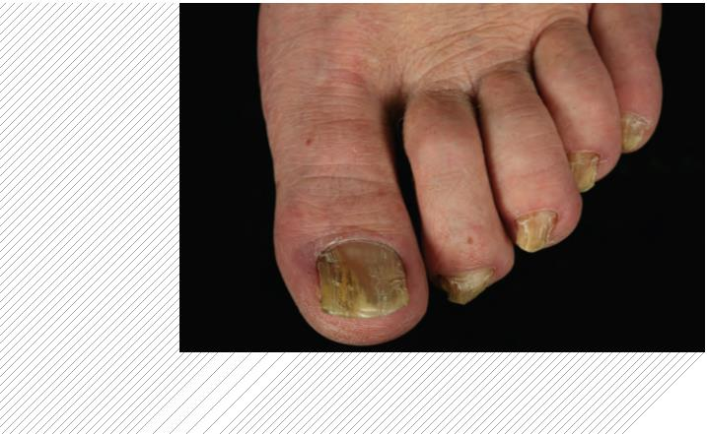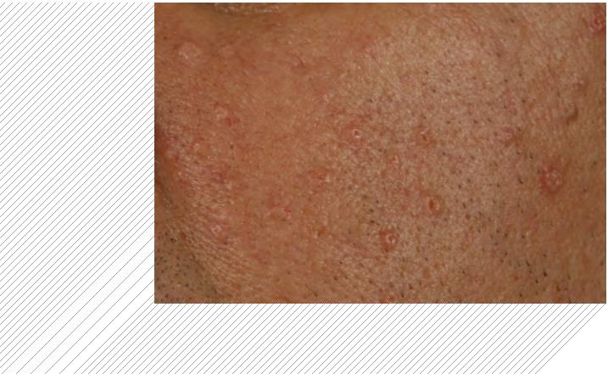

Fungal infection of the skin (tinea corporis or ringworm)
Pityriasis versicolor (yeast infection)
This appears as red, scaly, itchy patches on the body. It can
appear anywhere but is especially common on the trunk and in
the groin region.
This common yeast infection of the skin usually affects the chest
and back. As shown in the photograph, it often appears as slightly
itchy, scaly patches, which may be pale pink or brown in colour.
It is most common in the ﬁrst one to two years after a transplant.
Treatment for ringworm
It is important to have a diagnosis from a doctor before beginning
treatment so if you think you have ringworm contact your GP in
the ﬁrst instance. Treatment is usually the application of a cream
or shampoo.
Treatment for yeast infection
Treatment usually involves washing with an anti-fungal shampoo
and using an anti-fungal cream for several weeks. Sometimes
it may be necessary to use an anti-fungal tablet as well.
Ringworm
on the arm
Pityriasis
versicolor
on the back
12
13
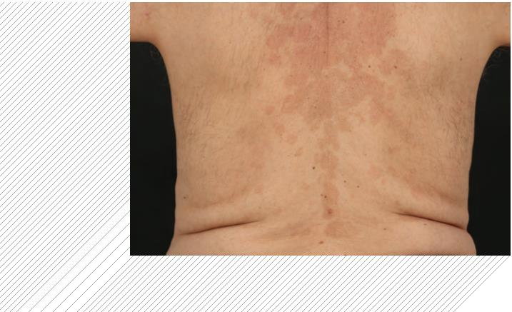

Other infections
Shingles and chickenpox (herpes zoster and varicella)]
Cold sores (herpes simplex)
Shingles and chickenpox are caused by the same virus. Both
can be more serious in people who have had a transplant.
Cold sores are very common and can cause more problems after
a transplant. They usually appear as painful blisters or ulcers that
always come back in the same part of the body such as on the lips,
nose or buttocks.
Shingles usually appears as a painful, blistering rash on a particular
area of the body, for example one side of the chest, the arm or on
one side of the face. Chickenpox is usually associated with feeling
unwell and a more widespread rash which eventually blisters.
Treatment for cold sores
Cold sores may need treatment with antiviral creams available over
the counter from a pharmacist. If they are still causing a problem
see your GP, who might prescribe tablets, and if they become very
troublesome contact your dermatologist.
Treatment for shingles and chickenpox
Treatment mainly involves antiviral medication but it is not
always required.
Shingles on
the right side
of the back
Cold sore in
the nose
]
If you think you may have developed either shingles or
chickenpox, especially if you have any form of blistering
rash, you should seek medical attention immediately.
Both are contagious and people with shingles can cause
chickenpox in those who have not previously had it.
14
15
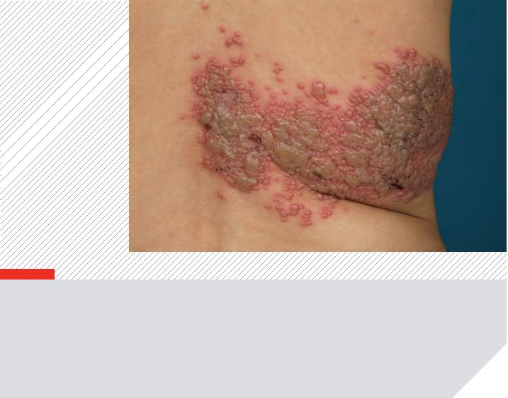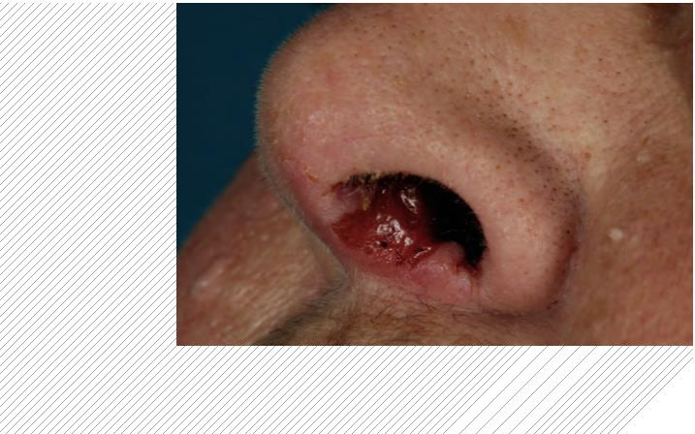

Viral warts
Warts on
These are very common after transplantation and are caused by
the human papillomavirus (HPV). Some people develop just one
or two warts – often on the hands or feet – while others can develop
large numbers that need specialist care. On the feet they are
known as verrucas.
the ﬁngers
Treatment for viral warts
Warts and verrucas can be difﬁcult to treat in organ transplant patients
but your GP or dermatologist will usually recommend one or all of the
following in the ﬁrst instance:
• Salicylic acid preparations (e.g. Salactol, Compound W, Cuplex,
Verrugon, Occlusal)
If none of these treatments work, more aggressive therapy may be
recommended such as:
• Freezing (cryotherapy)
• Efudix (5-ﬂuorouracil) cream
• Vitamin A creams (e.g. Retin A)
• Aldara (imiquimod) cream
Some very troublesome warts may need to be surgically removed,
but there is a risk that they may come back again. Very occasionally
reducing the amount of anti-rejection drugs taken, or using a tablet
called Acitretin, can help control warts. On the whole the aim is to
control rather than cure warts after a transplant.
16
17
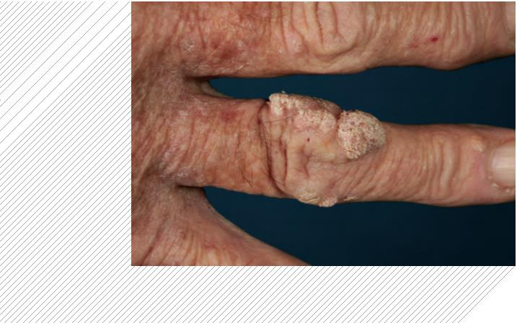

Benign (harmless) skin lumps
Seborrhoeic warts
Campbell de morgan spots (cherry angiomas)
These are harmless lesions with a warty, greasy, ‘stuck-on’
appearance. Seborrhoeic warts often appear on the back and chest
but they can appear anywhere on the skin, and there may be many
of them.
These are harmless overgrowths of blood vessels and do not require
treatment. They look like tiny, red, raised spots and are common on
the chest and abdomen, but can appear on any part of the body.
Treatment for seborrhoeic warts
Seborrhoeic warts do not usually require treatment but if they are
causing problems the warts can be frozen off (cryotherapy) or
removed surgically.
Seborrhoeic
wart
Campbell de
morgan spots
18
19
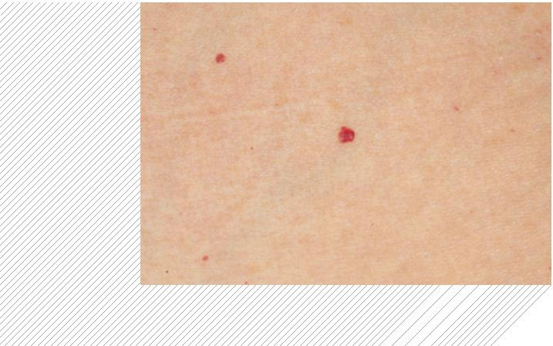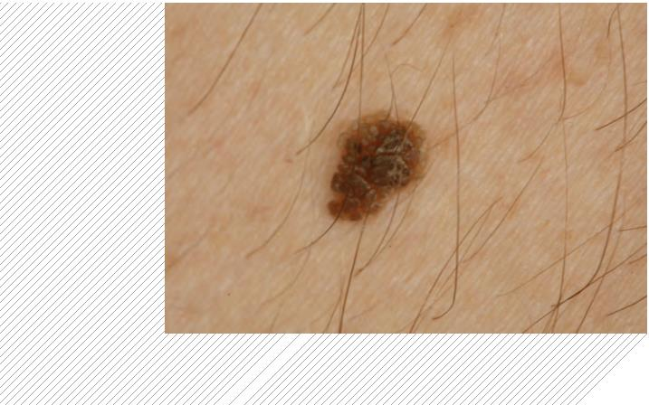

Pre-cancerous skin lesions
Actinic keratosis
Actinic keratosis (AK)
This is also known as solar keratosis as it tends to occur on
sun-exposed sites such as the hands, face and scalp. It appears as
small, dry, ﬂaky patches of skin, some of which can have a crust.
Sometimes this crust can fall off leaving a red area underneath.
Solar keratosis is usually painless but may be slightly itchy. If you
develop any tenderness or pain in the area you should seek medical
advice from your dermatologist.
The presence of actinic keratosis may be a sign that you are at
increased risk of skin cancer, and the condition has the potential
to develop into skin cancer. It is usually assessed and treated, if
necessary, within the dermatology department.
Treatment for actinic keratosis
Treatment includes the following options:
• Observation (watchful waiting)
• Freezing (cryotherapy)
• Solaraze (hyaluronic acid) gel
• Efudix (5-ﬂuorouracil) cream
• Aldara (imiquimod) cream
• Surgical removal
• Photodynamic therapy (PDT)
20
21
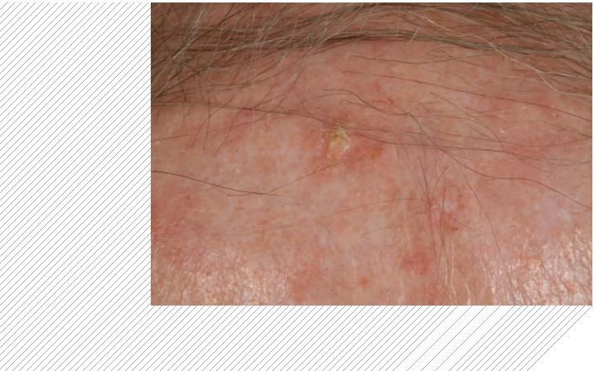

Bowen’s disease (carcinoma in situ)
Porokeratosis
Bowen’s disease or squamous cell carcinoma in situ (CIS) is commonly
found on the lower legs, hands, forearms and face. It appears as
crusty/scaly areas of reddened skin that may look a little like patches
of psoriasis, eczema or fungal infection. These areas can range in size
from small lesions the size of a pea, to large areas almost covering the
back of a hand. They can sometimes ulcerate.
Porokeratosis appears as raised, sometimes scaly, red rings.
They are often found on the lower legs and may look like patches
of psoriasis or fungal infection.
Very rarely porokeratosis can develop into a skin cancer, so if you
suspect the condition please contact the dermatology department
for advice.
The presence of Bowen’s disease may be a sign that you are at
increased risk of skin cancer, and these lesions have the potential to
develop into skin cancer. They are usually assessed, diagnosed and
treated, if necessary, within the dermatology department.
Treatment for porokeratosis
Treatment includes the following options:
• Observation (watchful waiting)
• Freezing (cryotherapy)
Treatment for Bowen’s disease
Treatment includes the following options:
• Efudix (5-ﬂuorouracil) cream
• Aldara (imiquimod) cream
• Photodynamic therapy (PDT)
• Observation (watchful waiting)
• Freezing (cryotherapy)
• Efudix (5-ﬂuorouracil) cream
• Aldara (imiquimod) cream
• Photodynamic therapy (PDT)
• Curettage and cautery
(minor surgery)
Bowen’s disease
Porokeratosis
22
23
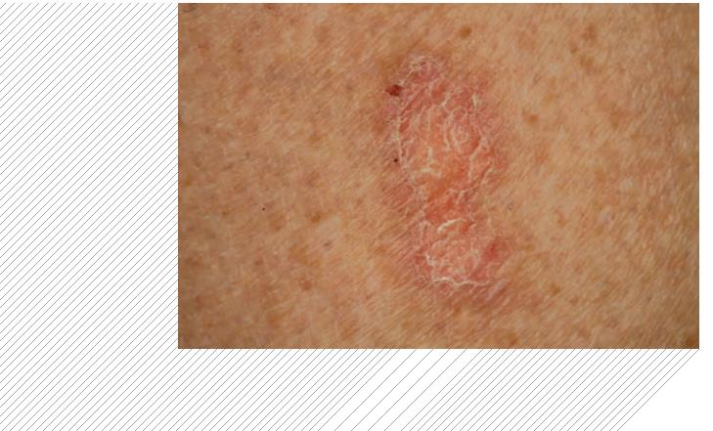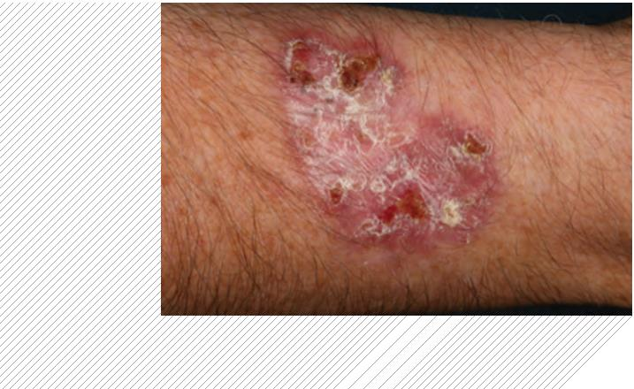

Skin cancer
Melanoma]
The four main types of skin cancer common in organ transplant
recipients are:
Melanoma is an uncommon tumour in organ transplant patients but it
is important to catch it early as melanoma can spread. Melanoma can
arise from a longstanding mole, or from a new mole that wasn’t there
before. If you notice any change in the shape, size, or colour of a
longstanding mole, or if you develop a new mole, it should be
examined by a dermatologist.
• Melanoma
• Squamous cell carcinoma (SCC)
• Basal cell carcinoma (BCC)
• Kaposi’s sarcoma (KS)
Treatment for melanoma
Surgery is the best treatment for melanoma.
All four types occur more frequently after transplantation, but the most
common are squamous and basal cell carcinomas.
The main cause of skin cancers is a combination of exposure to the
sun, which may have happened many years earlier, and
immunosuppressive drugs used to stop the transplanted organ from
being rejected.
Melanoma
Risk factors for skin cancer include:
• How long ago you were given a transplant. The longer you have
had your transplant, the greater the risk. About 50% of people who
have had a transplant for more than 20 years will develop some
form of skin cancer. However, it takes an average of eight to 10
years for skin cancer to ﬁrst appear.
• Age at transplantation. People over 50 years old when they were
given a transplant are at greater risk than people who were younger.
• Fair skin. Those with a tendency to burn and freckle in the sun are
at greater risk of skin cancer.
• High levels of sun exposure in the past. People at greater risk are
outdoor workers, those with outside hobbies, sunbathers, people
who have lived abroad somewhere sunny or have had many holidays
abroad, and sun bed users. A history of repeated sunburn is a
particular risk.
]
If you think that you may have melanoma, telephone
any of the dermatology department contact numbers
listed on page 37 as you will need to see
a dermatologist.
• The presence of actinic keratosis or Bowen’s disease.
24
25
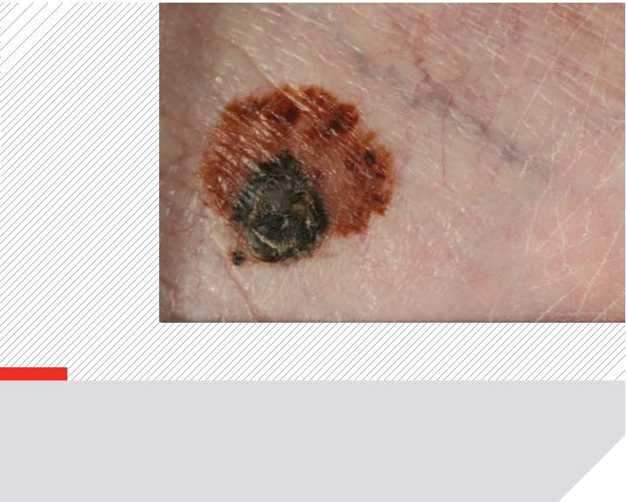

Squamous cell carcinoma (SCC)]
Squamous cell
carcinomas
Squamous cell carcinoma is the most common skin cancer in
transplanted patients, especially those with fair skin.
SCCs appear as red, crusty, raised lumps, bumps or ulcers.
Sometimes they may look like warts with a red base. They can be
tender or painful and they may bleed. SCCs can grow quite quickly,
for example double in size within two to three months, but this is not
always the case.
SCC is most common on areas of the body that are regularly exposed
to the sun, such as the face, ears, hands, and lower legs in women.
Transplant patients will often go on to develop more SCCs after the
first one appears.
Treatment for squamous cell carcinoma
There are four treatment options:
1. Surgical removal. These lesions can usually be removed by surgery
in the dermatology department. If the skin cancer is big, or in a difﬁcult
area such as the ears or eyes, plastic surgery may be necessary
combined with skin grafting. If left to grow, SCC can inﬁltrate deeper
and spread to the lymph glands.
2. Radiotherapy. This is occasionally used as an alternative, or in
addition, to surgery.
3. A reduction in immunosuppressive drugs. Sometimes organ
transplant patients can develop multiple squamous cell carcinomas.
If this occurs the dermatologists may ﬁnd out from the transplant
doctors whether it would be possible to reduce the dose of
immunosuppressive drugs.
]
4. Acitretin. In some cases a drug called acitretin may be prescribed to
slow down and prevent the development of these skin cancers.
If you think that you may have a squamous cell
carcinoma, telephone any of the dermatology department
contact numbers listed on page 37 as you will need to
see a dermatologist.
26
27
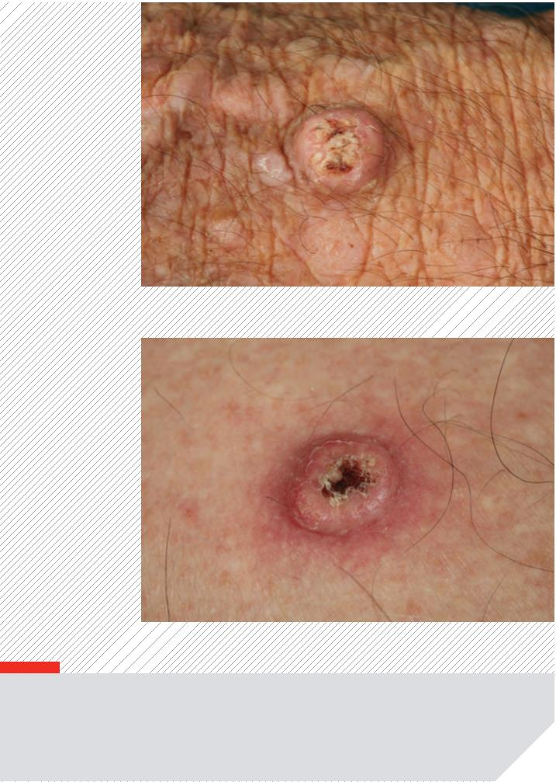

Basal cell carcinoma (BCC)]
Basal cell
Basal cell carcinoma lesions usually appear as shiny/pearly lumps
and are commonly found on the upper body and face, but they can
develop elsewhere. Occasionally they appear as crusting, sore areas
of skin that do not heal. The majority grow slowly and can take up to
a year to double in size.
carcinomas
Treatment for basal cell carcinoma
The treatment options are:
• Surgery
• Aldara (imiquimod) cream or Efudix (5- ﬂuorouracil) cream
• Cryotherapy
• Radiotherapy
]
If you think that you may have a basal cell carcinoma,
telephone any of the dermatology department contact
numbers listed on page 37 as you will need to see
a dermatologist.
28
29
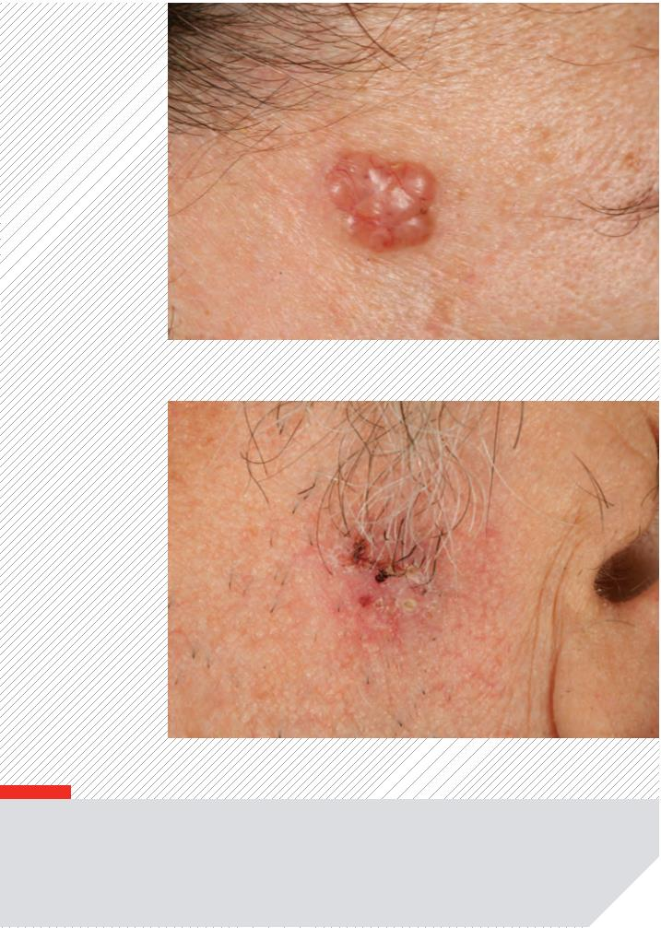

Kaposi’s sarcoma (KS)]
Kaposi’s
sarcoma
People from Africa, the Middle East, the Mediterranean and the
Caribbean have a higher risk of developing a type of skin cancer
known as Kaposi’s sarcoma. It is caused by human herpes virus
(HHV8), which is very common in these areas. The virus is often
picked up in childhood and lies dormant in the body until it is
reactivated and causes KS. This sarcoma tends to develop within
the ﬁrst ﬁve years of transplant.
Kaposi’s sarcoma may start with swelling of a limb, usually the
lower leg, and/or the development of dark lumps or spots.
These are commonly found on the legs and feet but can appear
anywhere. They are usually dark brown or purple but they can be
any colour from light brown to deep purple.
Treatment for Kaposi’s sarcoma
]
If you think that you may have Kaposi’s sarcoma,
Sometimes all that is needed is a reduction or change in
immunosuppressive drugs, but this can take several months to have
an effect. Occasionally additional treatments including surgical
removal, radiotherapy, and chemotherapy may be required.
telephone any of the dermatology department contact
numbers listed on page 37 as you will need to see
a dermatologist.
Please ask for our separate leaﬂet on Kaposi’s sarcoma if you
would like more information.
30
31
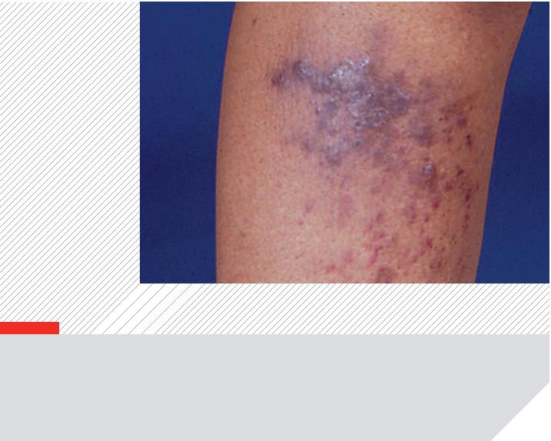

Skin cancer prevention
• A tape measure or ruler
• A digital camera to record any skin marks you are not sure about
It is important that you can recognise the early signs of skin cancer so
that the appropriate treatment can be given. The earlier these skin
growths are detected, the better the outcome.
To make sure that you check all your skin, we suggest you examine
yourself from head to toe following these steps. Use a mirror to check
difﬁcult-to-see areas or ask a friend or relative to help you.
Skin self-examination
Head
We recommend you examine your skin regularly, ideally at least once
a month. This means that if you notice any new lumps, bumps, marks
or growths on your skin they can be checked by a dermatologist and,
if necessary, treated early. Early detection can help to reduce the risk
of developing a larger, more serious skin cancer that may need
extensive surgery or treatment.
Beginning with your head, examine your scalp using a comb to part
your hair so you can check all over your scalp. Go on to look over your
face and neck. Don’t forget to check behind your ears and the back of
your neck.
Upper body
You should be looking for:
Check your shoulders, chest and abdomen, again using a comb to
part any hair to examine the skin underneath. Don’t forget to examine
under your breasts and in the groin area.
• New skin lumps, spots, ulcers, scaly patches or moles that weren’t
there before
• Marks (including moles) on the skin that have changed shape,
colour, texture or size
Arms and hands
Examine each arm in turn beginning with the hands. Look at both the
front and back of your hands and check between your ﬁngers (the web
spaces) and your ﬁngernails. Examine all around your upper and lower
arms (remember to use a mirror for places you can’t see) and raise
your arms above your head to check each armpit.
• Sores that do not heal
• Any areas on the skin that are itchy, painful or bleed
How to examine your skin
Ideally you should examine your skin in a warm, well-lit room with the
following equipment:
Back
• A chair
If you have someone who can look at your back for you that is the
easiest method of examination. If you want to do it yourself, use a
full-length mirror in conjunction with a hand-held mirror. Look at the
whole of your back starting at the top. Examine both shoulders to the
middle of your back. Working from each side to the middle, traversing
your back as you go, move down past your hips to your bottom.
• A full-length mirror
• A hand-held mirror
• A comb
32
33

Legs and feet
Example: Red bleeding lump, 16/5/14
Sit down to examine the front and sides of your upper and lower legs.
Remember to look at your groin area including the genitals. Look at
your feet, paying particular attention to the soles and between your
toes. Remember to check your toenails.
Recording what you ﬁnd
You might ﬁnd it helpful to use a non-permanent marker pen to draw
around any skin marks that you notice to see if they get any bigger, or
change in any way. Alternatively you could photograph them.
You can record any skin changes that you are worried about on these
diagrams of the front and back of the body. As shown in the example
here, draw a small circle on the diagram in the approximate position
you found the skin problem. Write down the date that you noticed it,
and any other remarks such as ‘bleeding’ or ‘itchy’. This will help
remind you and assist the dermatologist when they see you at your
next visit.
If you notice any new lump, bump, ulcer, sore, scaly patch or changing
mole that lasts for longer than 2–3 weeks, contact your dermatologist
for advice.
34
35
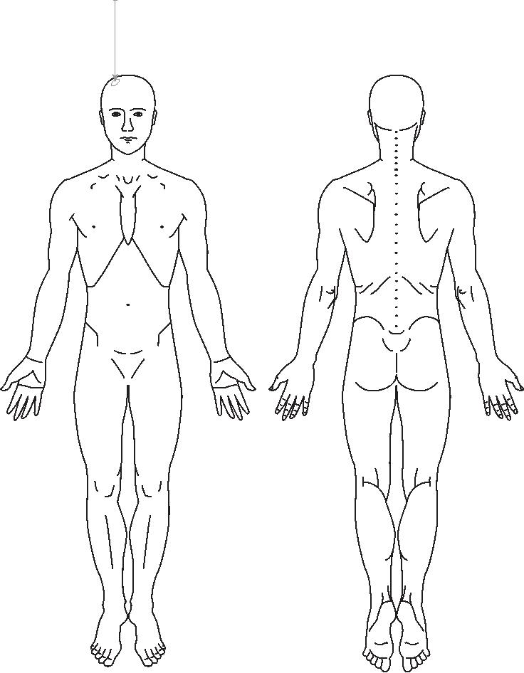

Sun protection
Further information
It is important to protect your skin from excessive sun exposure.
The three golden rules are:
British Association of Dermatologists
(BAD) gives information about skin care to pre-transplant
and transplant patients.
1. Prevent yourself from burning in the sun
2. Avoid sunbathing
www.bad.org.uk
British Society for Skin Care in Immunosuppressed
Individuals (BSSCII) gives information on skin care for
patients and health professionals.
3. Do not use artiﬁcial tanning beds
From April to October you should cover your body as much as
possible by using a hat, long-sleeved clothing and sunglasses. Some
people ﬁnd wearing gloves helpful too.
www.bsscii.org.uk
International Transplant Skin Cancer Collaborative
offers information on skin care and transplant medication.
www.itscc.org
Use a good quality sunscreen, with at least SPF 30–50 and a
4-star rating (this information can be found on the product), on all
sun-exposed areas and stay in the shade. Note that between
11am–3pm the sun is particularly intense.
Cancer Research UK
for free information about cancer and cancer care.
Sunscreens currently available on prescription from your GP are:
Cancer Research UK
PO Box 123
• Sunsense® Ultra
....
(UVB SPF 50+)
• Uvistat®
..........................
(UVB SPF 30 and 50+)
....................
(UVB SPF 50+)
Lincoln’s Inn Fields
London WC2A 3PX
• Anthelios®
Tel: (Supporter Services) 0808 800 4040
www.cancerhelp.org.uk
• Delph®
.............................
(UVB SPF 30+)
Macmillan Cancer Support is a cancer information
and support charity.
Vitamin D
Macmillan Cancer Support
89 Albert Embankment
London SE1 7UQ
People who need to take extra precautions to reduce sun exposure
may become deﬁcient in vitamin D which is important for the healthy
function of the body. Vitamin D is produced in the skin after sun
exposure and is found in foods such as oily ﬁsh. If you think you may
be at risk of vitamin D deﬁciency talk to your GP or transplant doctor.
Tel: (Supporter Services) 0808 808 0000
http://www.macmillan.org.uk/home.aspx
36
37

Patient diary
Please use this diary to keep a record of your clinic visits
Comments
Next appointment
Visit date Outcome (treatment etc)
Write down anything you want to mention
at your next visit
Date
Time
38
39

Comments
Next appointment
Visit date Outcome (treatment etc)
Write down anything you want to mention
at your next visit
Date
Time
40
41

Comments
Next appointment
Visit date Outcome (treatment etc)
Write down anything you want to mention
at your next visit
Date
Time
42
43

Please bring this booklet with you
to all clinic visits
©Barts Health NHS Trust
Switchboard: 020 3416 5000
www.bartshealth.nhs.uk
Produced by Medical Illustration
The Royal London Hospital
020 3594 2189
medillustration1@btconnect.com
Publication date: December 2014
