Skin Cancer Risks in
Transplant Recipients:
Know the Facts
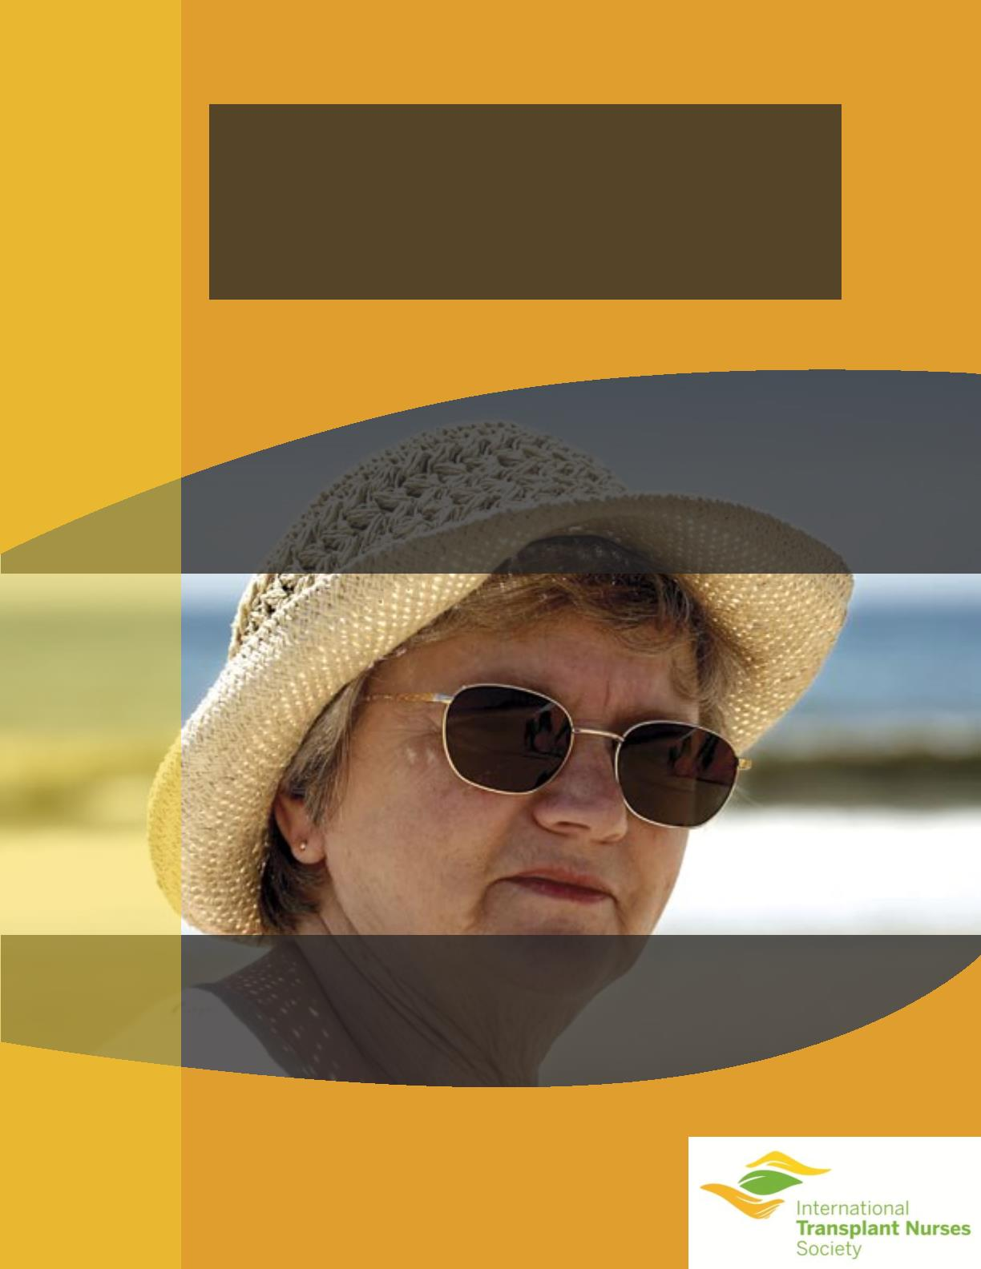

What is skin cancer?
The skin is the body’s largest organ. It protects against
heat, sunlight, injury and infection, controls body
temperature and stores water, fat, and vitamin D.
The skin has several layers. The main layers are the
epidermis (outer layer) and the dermis (inner layer). The
epidermis contains three kinds of cells — ﬂat, scaly cells
on the surface called squamous cells, round cells called
basal cells, and cells called melanocytes which give your
skin color. Skin cancer can occur anywhere on the body,
but is most common in skin that has been in the sunlight
such as the face, neck, hands and arms. There are several
types of cancer that affect the skin. The most common
types are the basal cell carcinoma and squamous cell
carcinomas.
Why should I be concerned?
Skin cancer is the most common
cancer in organ transplant recipients.
Solid organ transplant recipients are
up to 65 times more likely to develop
skin cancer then the general public.
It is estimated that up to 70% of fair-
skinnned transplant recipients will
develop skin cancer within 20 years
of their transplant but can usually be
treated effectively.
The risk is increased because
immunosuppressive medications
necessary for survival for your
organ suppress the immune system,
thus preventing your body from
rejecting your transplanted organ. By
suppressing the immune system these surgeries can be burdensome.
medications all increase the risk for
skin cancer.
For high risk transplant patients skin
cancer can become a severe problem.
Repeat surgeries for skin cancer can
signiﬁcantly decrease the quality of
life. Patients may develop new skin
cancers regularly and the frequent
Also, removal of skin cancers may
cause scarring, sometimes affecting
appearance. When skin cancer
severely affects an organ transplant
patient, immunosuppressive
medication may be reduced or
changed and preventive medications
may be administrated.
The main cause of skin cancer is
damaged skin from exposure to
ultraviolet radiation from the sun
or from artiﬁcial tanning. This
ultraviolet radiation can penetrate
skin and damage the skin cells over
time.
What are the risk factors for skin cancer?
All transplant patients are at increased risk to develop skin cancer. However
transplant patients with the following characteristics are at greater risk for skin
cancer. These characteristics are:
• Older individuals
• Men
• Fair and easily burned skin
• Freckled skin
• Red and blonde hair
• People who have outdoor occupations
or extensive exposure to the sun
• Family history of skin cancer
• Personal history of skin cancer
• Blue, green or hazel eyes
2
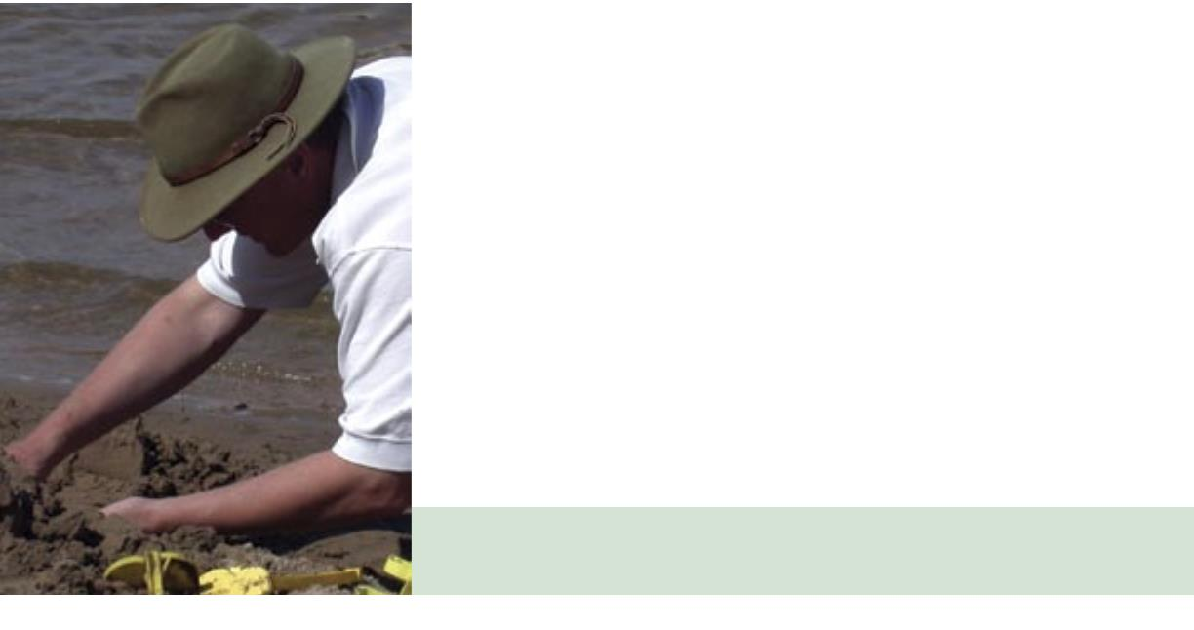
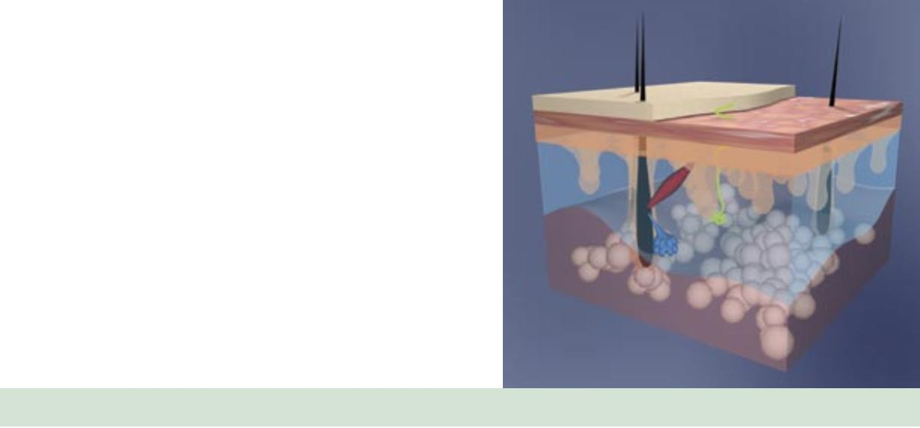

How quickly does skin cancer develop after organ
transplant?
The majority of fair-skinnned organ transplant patients will eventually develop
skin cancer. After a transplant, there is generally a lag time of 3-7 years before
skin cancers begin to develop. This period of time may vary depending
upon individual risk factors. The longer a person takes immunosuppressant
medications, the greater the risk of skin cancer. In temperate climates 40% of fair-
skinnned patients develop skin cancer within 20 years after transplantation. In
warmer climates, up to 70% of fair-skinnned patients develop skin cancer within
20 years after transplant.
Can I lower my risk of developing skin
cancer?
You can’t change your skin, but you can lower your risk
of skin cancer by following the sun protection precautions
outlined below. Also, all skin cancer passes through a
treatable phase before getting worse. Having your skin
cancer treated early is essential to maintaining your health.
Sun protection is the best strategy for preventing skin
cancer. Unfortunately only 54% of transplant patients
remember receiving skin cancer education and only 40%
regularly use sunscreen.
To maintain healthy skin and prevent skin cancer the following measures are recommended:
• Apply a broad spectrum sunscreen with a sun protection factor of at least 30 or higher.
• Make sunscreen a part of your normal morning routine.
• Clothing provides excellent protection from sun damage. Wear long sleeved shirt and long pants when possible.
• Regularly wear a wide brimmed hat and sunglasses with UV protection.
• Limit outdoor activity between 10 AM and 4 PM.
Sunscreen in cosmetics is a good way to assure regular use. Apply the sunscreen to all exposed areas, including your face,
ears, dry part of lip, neck and the back of your hands. Men with thin hair should apply it to their scalps.
On the ﬁrst day of each month you should do a self examine of your skin with the help of mirrors or a partner. Look for
any new or changing growths including pink patches or spots, scaly growths, bleeding areas or changing moles. Report
them to your dermatologist, physician or transplant coordinator/nurse. Prompt attention can literally save your life.
3
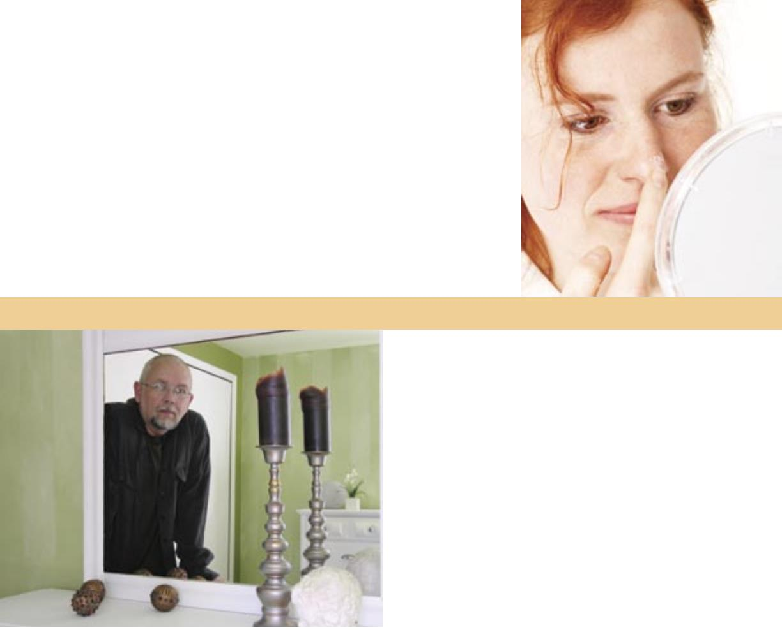

What does skin cancer look like?
Sunscreen
Skin cancer is the most common of all cancers, with more than one million skin
cancers diagnosed each year in the United States. Often, a precancerous condition
called, “actinic keratosis” precedes the development of skin cancer. Learning the
characteristics of actinic keratosis and the three most common forms of skin cancer is
essential to stay healthy.
Using sun protection will help
prevent skin damage, wrinkles
and reduce the risk of cancer.
Tips for Sun Protection:
1.
Use a broad-spectrum
sunscreen with an SPF
of at least 30 or higher
on all exposed skin,
including the lips, even
on cloudy days.
Fig. 1
Fig. 2
2. If exposed to water,
either through swimming
or sweating, a water-
resistant sunscreen
should be used.
Fig. 3
Fig. 4
3.
Reapply sunscreens
frequently - every 1-1/2
hours, more often if sunny
or heavily perspiring.
Actinic Keratosis (see ﬁgure 1)
(ak-tin’-ik ker-e-to’-sis)
Actinic keratoses are considered
Squamous Cell Carcinoma (see ﬁgure 3)
(skua’-mas sel kar-se-no’-ma)
Squamous cell carcinomas are the most
4. Wear a broad-brimmed
hat and sunglasses.
5. Seek shade wherever
possible.
6. Wear protective, tight-
woven clothing.
7. Plan outdoor activities
early or late in the day to
avoid peak sunlight
between 10am and 4pm.
“precancerous”. They have the potential common skin cancers in organ transplant
to turn into squamous cell carcinoma,
a common type of cancer. An actinic
keratosis appears as a small pink or
red spot with rough surface, usually on
sun-exposed areas. They are often more
easily felt than seen. Early treatment
of these pre-cancers can prevent their
transformation into more serious
squamous cell carcinomas.
patients. They can appear similar to
basal cell carcinomas, but are usually
more scaly and rough, and jut out further
from the skin’s surface. Squamous cell
carcinomas often occur on the head and
neck, but have a tendency to grow on the
ears, lips and the back of the hands and
arms. If treated early, a squamous cell
carcinoma is easily curable. However, if
the tumor invades deep into the skin, it
can spread to the lymph nodes, requiring
extensive treatment. If the treatment
is not successful, a squamous cell
Sunscreens work by absorbing,
reﬂecting or scattering the
Basal Cell Carcinoma (see ﬁgure 2)
(ba’-sel sel kar-se-no’-ma)
sun’s rays on the skin. They
are available in many forms
including ointments, creams,
gels, lotions and sprays. All are
categorized by SPF numbers.
The higher the SPF, the greater
the protection from sunburn,
caused mostly by UVB rays.
Some sunscreens called “broad-
spectrum” reﬂect both UVA and
UVB rays. Sunscreens should
be applied about 1/2 hour
before going outdoors.
This type of skin tumor usually appears
as a small, pink bump or patch on the
head or neck, although they may occur
on any part of the body. Untreated, the
area will begin to ulcerate, bleed or crust
repeatedly. Basal cell carcinomas grow
slowly and rarely spread to other parts
of the body. However, left untreated, a
basal cell carcinoma can cause extensive
damage to the area involved.
carcinoma can result in death.
Malignant Melanoma (see ﬁgure 4)
(ma-lig’-nent mel-e-no’-ma)
Malignant melanoma usually appears
as an irregular brown, black and/or red
spot or changing mole. Each year, 59,000
Americans develop melanomas and
7,900 Americans die from melanoma. If
caught early, melanoma is also curable.
However, in about 15% of patients, it
spreads to other parts of the body and
can result in death.
4
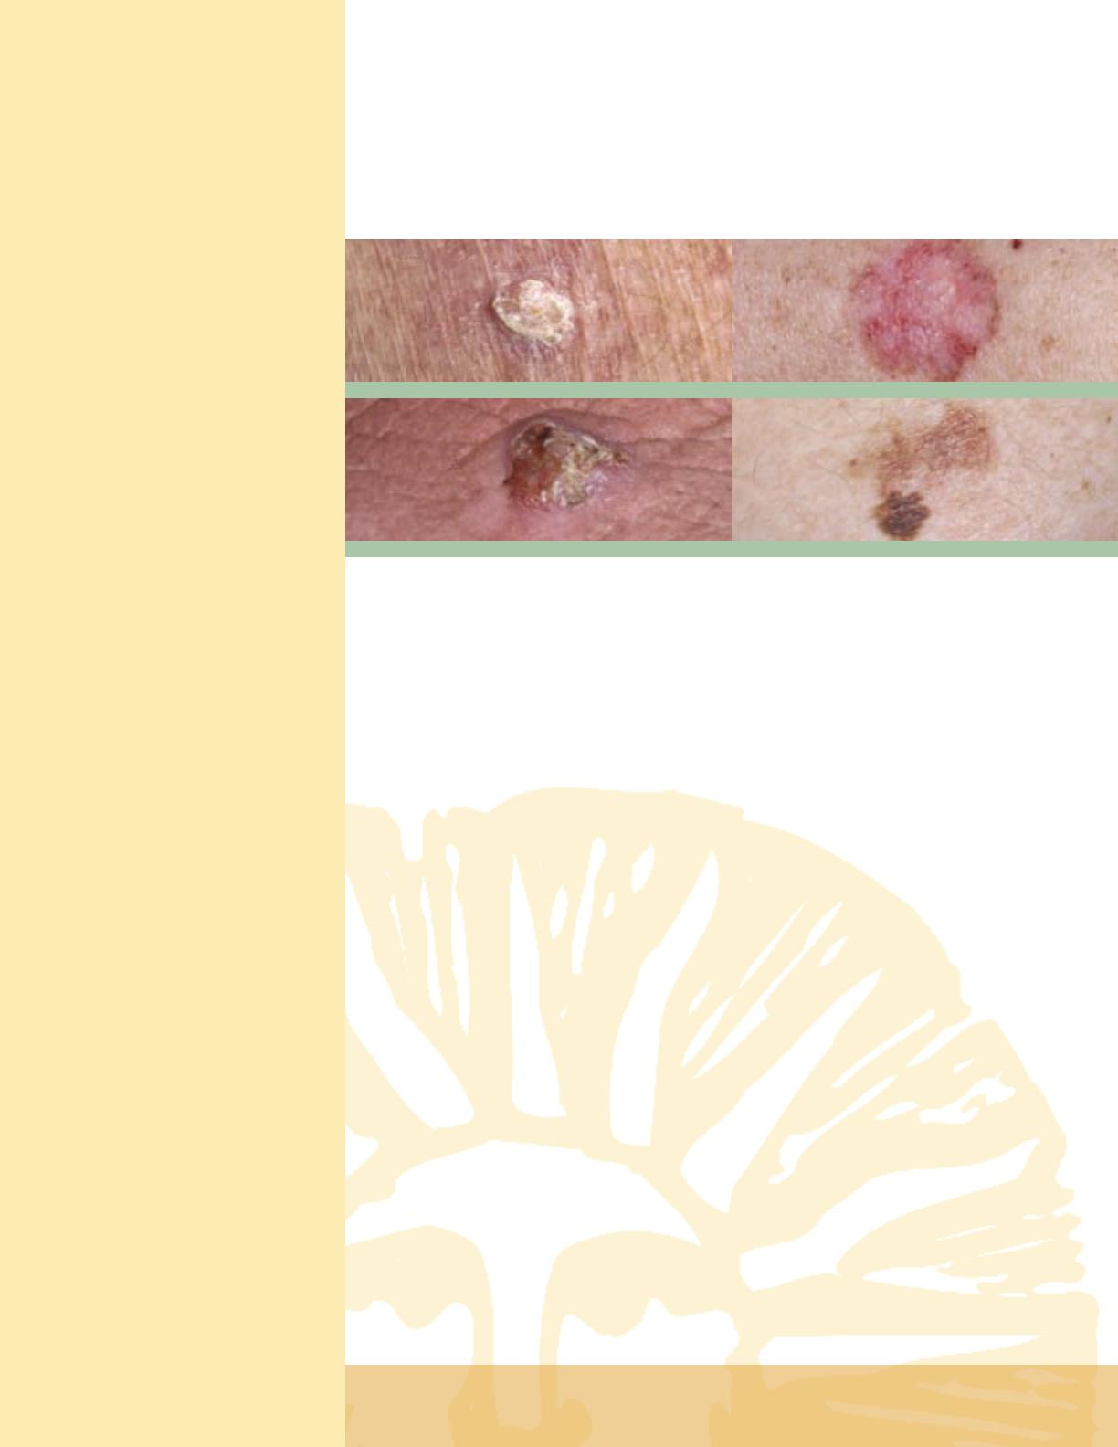

Choosing the right
sunglasses
Choosing the right sunglasses
will prevent long-term
exposure to the sun’s
ultraviolet rays which occur
during all seasons of the year.
These rays have been linked
to cataracts and macular
degeneration.
What are the treatments for skin cancer?
If caught early, skin cancers are almost always curable. Basal cell carcinomas and
squamous cell carcinomas can be treated with a variety of methods including
scraping and freezing for early skin cancers and surgical removal for more
advanced cancers. Melanoma is treated by surgically removing the growth. Mohs
micrographic surgery is a special surgical procedure used to ensure the complete
removal of a skin cancer, while sparing normal skin.
Sunglasses should:
• provide maximum
protection from
Ultraviolet (UV) rays
• block at least 98 percent
of the sun’s UV rays
• carry an American
National Standards
Institute (ANSI) label
listing how much UV
light they block.
Although the surgical removal of skin cancers inevitably leaves scars, appearance
can usually be restored to a high degree after skin surgery.
What are the long term complications of skin
cancer?
Most skin cancer is treatable without
long term complications. However,
if prompt treatment is not successful,
then the skin cancer may spread to
the lymph nodes, requiring surgical
removal of the nodes. If that treatment
is not successful, then the cancers
can spread to other parts of the body,
resulting in death. With successful
and early treatment, the vast majority
of patients have their skin cancers
managed well. However, even with
successful treatment, multiple skin
cancers can be a real burden for
patients. The treatment may require
multiple surgical procedures resulting
in frequent healing, and may produce
scars which can alter appearance.
Having skin cancer is no fun;
Note: Sunglasses claiming
maximal UV protection
don’t necessarily meet ANSI
standards.
Polarized lenses
• provide extra comfort
for your eyes and block
glare from such things
as pavement, sand,
water, snow or the hood
of your car.
prevention is the best approach.
Living with skin cancer
Unlike most cancers, which may happen at
most once during a lifetime, skin cancers
may develop dozens or even hundreds
of times in affected patients. Therefore,
treatment by a dermatologist should be an
ongoing process. Your dermatologist will
work with you to try to catch skin cancers
early, and use preventative techniques to
reverse precancerous changes to prevent
skin cancer. You can help by protecting
your skin from sun damage and checking
it on a monthly basis. If you see a
• most provide protections
from UV rays.
Fit close to your face
• wraparound sunglasses
give more complete
protection from all
angles of light.
suspicious skin spot, have it checked by
your dermatologist or transplant provider.
5
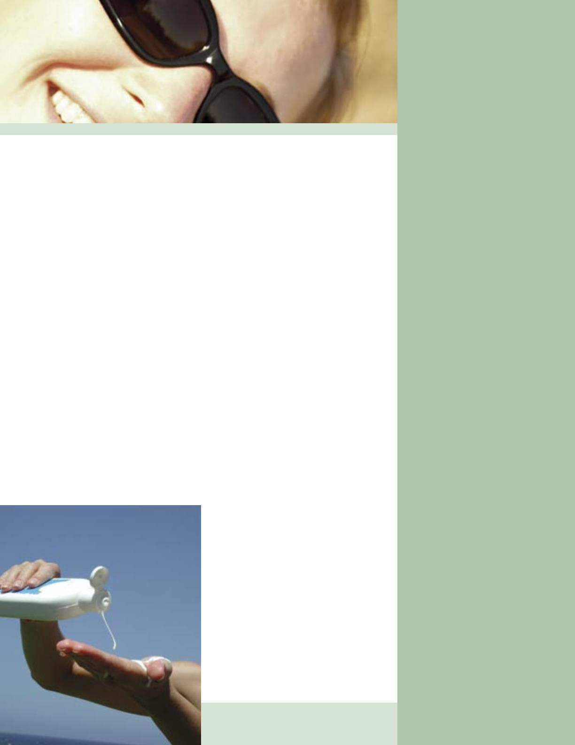

Related Links for More Information
These sites are provided as a network resource. Information from the Internet in
regard to your transplant should always be discussed with your transplant team.
ITNS is not responsible or liable for any information received from these websites.
For More Information:
International Transplant Skin Cancer Collaborative
www.itscc.org
AT-RISC Alliance (After Transplant-Reduce the Incidence of Skin Cancer)
www.at-risc.org
SCOPE (Skin Care in Organ Transplant Patients-Europe)
www.scopnetwork.org
The Skin Cancer Foundation
www.skincancer.org
American Academy of Dermatology
www.aad.org
American Cancer Society
www.cancer.org
National Cancer Institute
www.cancer.gov
This project is supported by an unrestricted educational grant from Connetics.
ITNS gratefully acknowledges their support of this educational endeavor for
improving patient care.
Contributors:
Bonita Potter, RN, CCTC
Barb Schroeder, MS, RN, CNS, APRN-BC
www.itns.org
++(412) 343-ITNS
itns@msn.com
Printed in the USA
7.5K 7/06

